

KA-DAH
The Invisible App

Complete Product Design Specification
Sections 1-20

A fully non-visual mobile experience designed for dignity, autonomy, and independence.

Prepared by Oplene Group Pty Ltd
December 2025

Table of Contents

Section 1: Introduction and Design Philosophy
KA-DAH is a fully non-visual mobile application designed to serve users who are blind or visually impaired by replacing the traditional graphical user interface with an interaction model rooted in audio, haptics, and simple gestures.

Core Principle: The screen remains fully blank throughout use, and the phone surface becomes the interactive canvas. This structure removes reliance on sight, reduces cognitive load, and ensures users can operate independently.

1.1 Foundational Pillars
The design philosophy is informed by leading research from RNIB, WCAG 2.2, and Apple's Accessibility Human Interface Guidelines:
- Autonomy: Removing the need for precise touch targets or visual scanning
- Predictability: Consistent haptic patterns and sound cues for navigation
- Simplicity: Minimal spoken prompts, universal gestures
- Dignity: Invisible interface respects the user's desire for discreet technology use

1.2 The Invisible Interface Concept
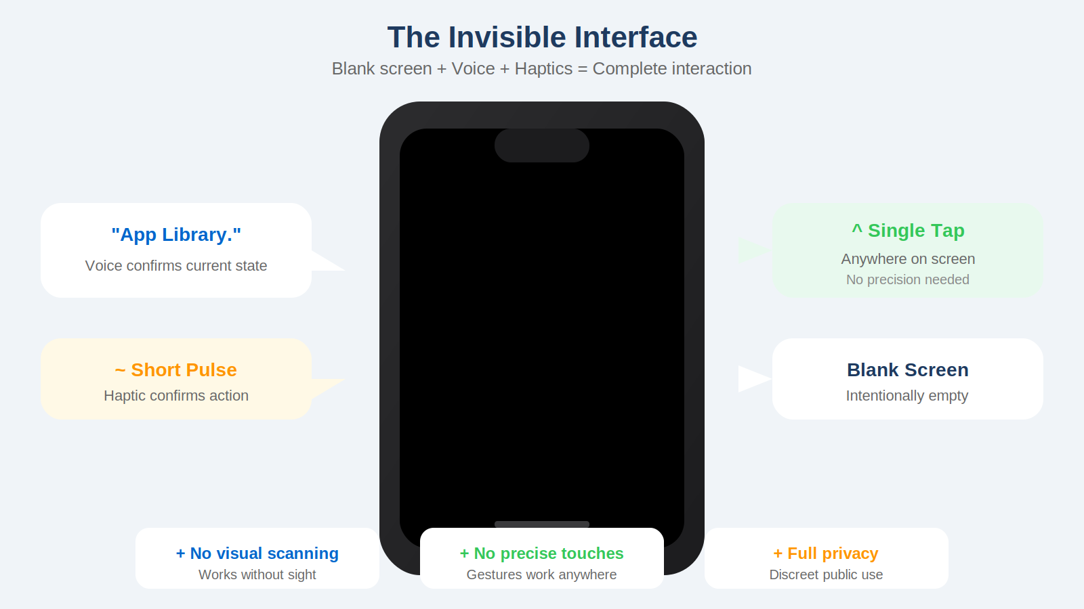
Figure 1.1: The Invisible Interface - Blank screen with voice and haptic feedback

KA-DAH is not an app that compensates for a visual deficiency; it is an app that elevates auditory and tactile strengths. The invisible interface sits on a structured system of states, each presenting the user with concise audio cues, predictable haptic responses, and consistent gesture controls.

Section 2: The Invisible Interface Model
KA-DAH introduces an interface paradigm specifically engineered for users who are blind or visually impaired: an interface that is fully functional despite the absence of visible elements.

2.1 Three Communication Channels
The invisible interface operates through three integrated channels:

- Audio Confirmations: Short, efficient sound cues and minimal spoken prompts to provide orientation
- Haptic Signals: Tactile reinforcement of every major state with consistent vibration patterns
- Simple Gestures: Four universal gestures that can be performed anywhere on the screen

2.2 Haptic Model
The haptic system provides predictable feedback:
- Single short vibration: Successful action confirmed
- Two pulses: Navigation or progression
- Longer vibration: Critical alerts or confirmations

2.3 Audio Philosophy
Research from RNIB and WCAG emphasizes reducing verbosity to avoid cognitive fatigue. KA-DAH uses concise language only where necessary; in all other cases, it communicates through tones or vibrations.

Section 3: App Store Acquisition Journey
This section documents the complete process through which a visually impaired user acquires KA-DAH on both Apple and Android devices.

3.1 iOS: Siri-Based Acquisition
Siri provides the fastest acquisition pathway:
- User says: 'Hey Siri, open the App Store'
- User says: 'Hey Siri, search for KA-DAH'
- User says: 'Hey Siri, download KA-DAH'
- Authentication via Face ID, Touch ID, or password
- Short vibration confirms download initiation

3.2 Android: Google Assistant Acquisition
On Android devices, Google Assistant offers a hands-free pathway:
- User says: 'Hey Google, open the Play Store'
- User says: 'Hey Google, search for KA-DAH'
- TalkBack reads the app details and Install button
- User says: 'Tap Install' or double-taps

3.3 Store Metadata
KA-DAH's store presence is designed as an extension of its invisible interface philosophy. All screenshots include descriptive ALT text clarifying that the interface is intentionally blank.

Section 4: Daily Startup Methods
KA-DAH is designed to be launched effortlessly each day through reliable, repeatable, and entirely non-visual pathways.

4.1 iOS Startup Options
- Siri Shortcut: 'Hey Siri, open KA-DAH' - instant launch
- Triple-Click Side Button: Accessibility shortcut activation
- VoiceOver Navigation: Swipe to find and double-tap to open
- Widget-Based Launch: Quick access from Today View

4.2 Android Startup Options
- Google Assistant: 'Hey Google, open KA-DAH'
- TalkBack Shortcut: Two-finger hold plus power button
- Home Screen Navigation: TalkBack exploration and double-tap
- Pinned Shortcut: Quick widget access

4.3 Haptic Confirmation
All startup methods conclude with a short vibration confirming KA-DAH has opened successfully, followed by the Home State announcement.

Section 5: Full Onboarding Experience
The onboarding experience is delivered through audio cues, haptic signals, and simple gestures. It introduces core patterns and prepares users for sustained independent use.

5.1 First Launch
Upon opening KA-DAH for the first time, the user encounters a completely blank screen. A soft chime signals successful opening, followed by a short vibration confirming system readiness.

Welcome Audio: 'Welcome to KA-DAH. This is a fully invisible app designed for touch, sound, and haptics. Tap anywhere to begin.'

5.2 Gesture Training
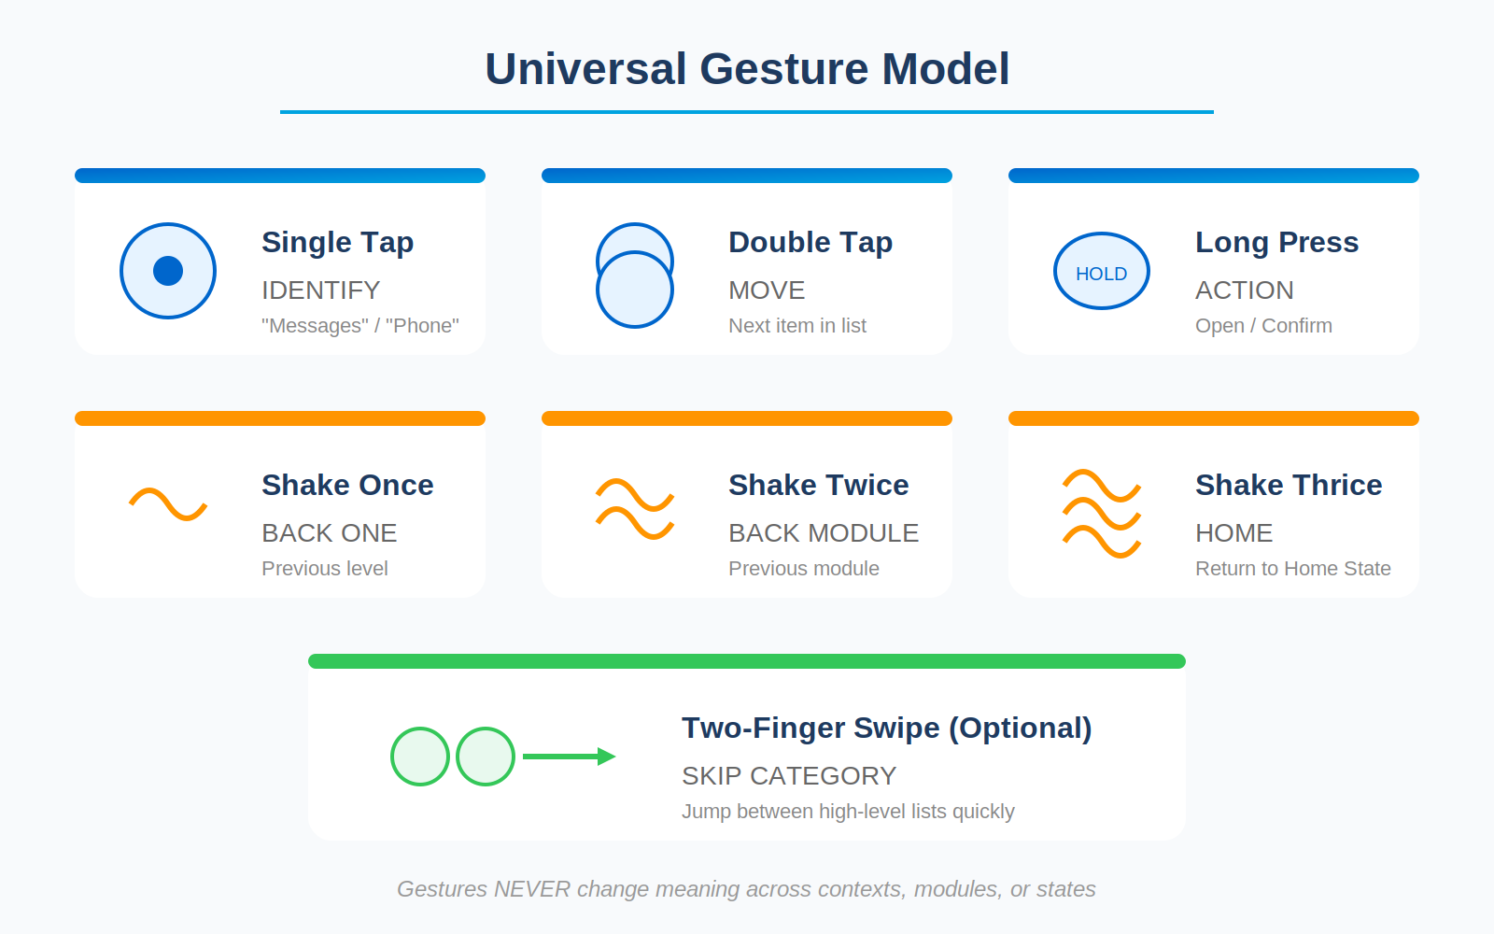
Figure 5.1: Universal Gesture Model - Five gestures with consistent meanings

5.2.1 Single Tap: Confirmation
User hears: 'Tap once.' Upon tapping, a brief vibration confirms recognition. 'Good. Tap means confirm.'

5.2.2 Double Tap: Progression
User performs double tap, receives two quick pulses. 'Good. Double tap means next.'

5.2.3 Long Press: Options
User holds anywhere, receives longer vibration. 'Good. Long press gives you options.'

5.2.4 Shake: Exit
User shakes phone gently, receives strong pulse. 'Good. Shake means back.'

5.3 Personalization
After gesture training, KA-DAH captures the user's name and most-used apps through voice input, creating a personalized experience.

Section 6: Dual-Mode Home State
The Home State serves as the foundational anchor of the KA-DAH experience, offering stability and minimal cognitive load.

6.1 Structure
The Home State presents two high-level, sequential options:
- App Library - Access to installed applications
- Web Content - Access to news, jobs, search, and AI tools

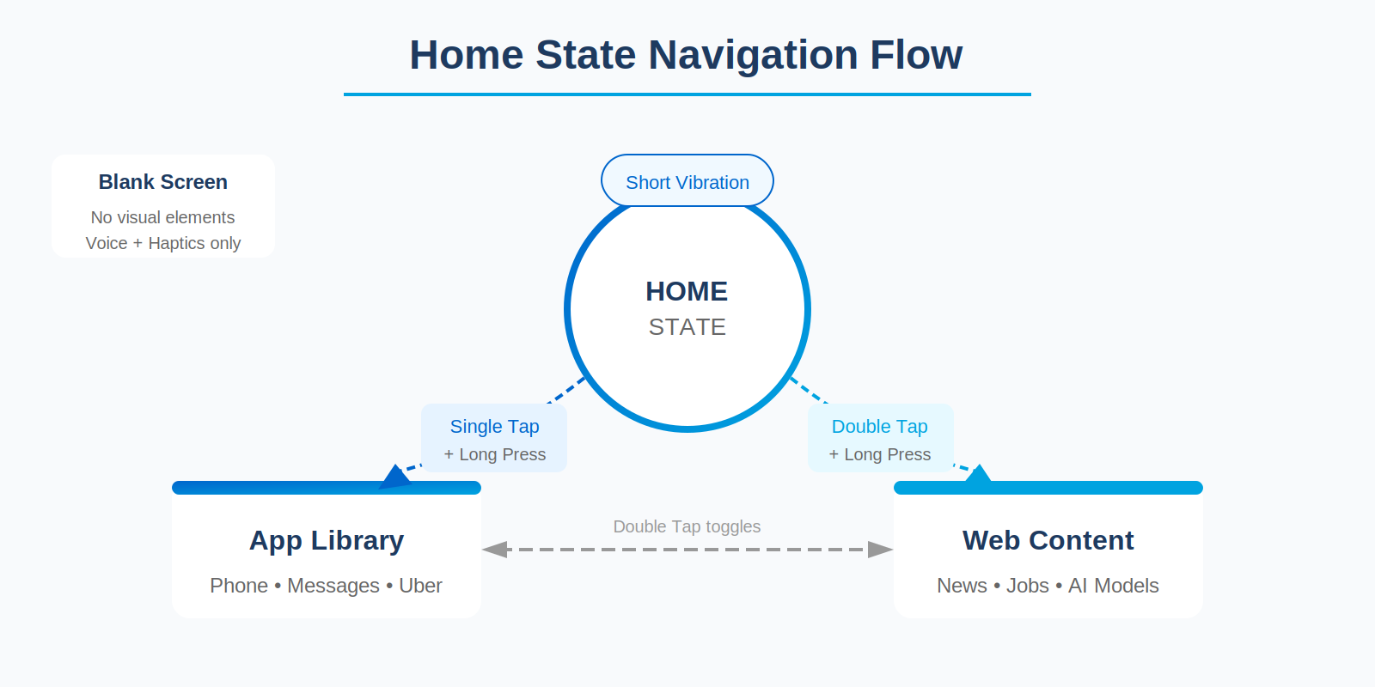
Figure 6.1: Home State Navigation Flow

6.2 Gesture Logic
- Single Tap: 'App Library' announcement
- Double Tap: Switch to 'Web Content'
- Long Press: Enter selected option

6.3 Global Exit and Recovery
KA-DAH offers universal escape mechanisms:
- Shake Once: Go back one step
- Shake Twice: Return to previous module
- Shake Three Times: Return to Home State

Section 7: Core Modules Overview
KA-DAH's functionality is organised into two interconnected ecosystems: App Modules and Web Content Modules.

7.1 App Modules
App Modules allow users to operate key mobile applications through the invisible interface:
- Phone - Voice-activated calling
- Messages - Sequential message navigation
- WhatsApp - Voice note playback and reply
- Uber/Bolt - Simplified ride-hailing
- Maps - Audio and haptic navigation
- Settings - Preference customization
- Help - Contextual assistance

7.2 Web Content Modules
Web Content Modules serve as an invisible browsing engine:
- News - Headlines from user-specified sources
- Stories - Long-form content and features
- Education - Tutorials and learning materials
- Jobs - Position listings
- Health - Trusted medical content
- Search - Voice-activated web search
- AI Models - ChatGPT, Claude, Gemini access

7.3 User-Defined Sources
During onboarding, KA-DAH asks: 'Please say the websites you use to read news, learn, or search for information.' These form the personalized Web Content Library.

Section 8: Categorised App Library
The App Library is organised into high-level categories to avoid overwhelming linear lists.

8.1 Universal Gesture Model
KA-DAH has five gestures only. They never change meaning:
- Single Tap: IDENTIFY - Announces current item
- Double Tap: MOVE - Advances to next item
- Long Press: ACTION - Opens, confirms, or triggers voice input
- Shake (1/2/3): BACK - Returns to previous level, module, or home
- Two-Finger Swipe: SKIP - Jumps categories quickly (optional)

8.2 Category Structure
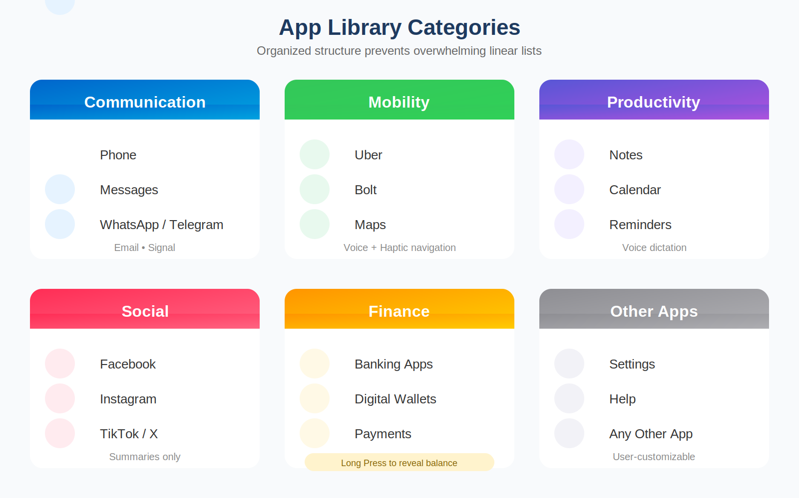
Figure 8.1: App Library Categories

8.3 Communication Category
Apps: Phone, Messages, WhatsApp, Telegram, Email, Signal

Phone Flow
- Long Press: Opens Phone
- KA-DAH: 'Say the name or number'
- User speaks the contact
- KA-DAH confirms: 'Calling [Name]'
- Short pulse: Connected; Long pulse: Ended

Messages Flow
- Long Press: Opens Messages
- KA-DAH: '2 conversations. Tap to hear first.'
- Single Tap: Read summary
- Double Tap: Next conversation
- Long Press: Reply with voice

Section 9: Web Content Flows
This section describes how VI users access the web through KA-DAH's invisible layer. All interactions respect the universal gesture model.

9.1 Top-Level Web Categories
- News - Current events and headlines
- Stories - Human-interest and features
- Education - Learning materials
- Jobs - Employment listings
- Health - Medical information
- Local Content - Regional news
- Search - Web search engines
- AI Models - ChatGPT, Claude, Gemini

9.2 News Module Flow
Inside News:
- Single Tap: 'Top stories'
- Double Tap: Next section (Local news, World news, etc.)
- Long Press: Enter selected section

Inside an article:
- KA-DAH reads paragraph by paragraph
- Single Tap: Repeat paragraph
- Double Tap: Next paragraph
- Long Press: Save or share
- Shake: Exit article

9.3 Search Module
Search is triggered by Long Press:
- KA-DAH: 'Say what you want to search'
- User speaks query
- Results returned as summarized list
- Navigate with Tap/Double Tap/Long Press

9.4 AI Models Module
AI platforms transform into voice-first cognitive companions:
- Long Press: Enter AI Models
- Single Tap: Identify first model
- Double Tap: Next model
- Long Press: Open selected model
- Long Press again: Activate voice input
- KA-DAH returns summarized answer
- Long Press: Request full answer

Section 10: Home State and Daily Start-Up
The Home State is the foundation of KA-DAH - the first moment each morning, the safety anchor throughout the day, and the organizing center for all access.

10.1 Role of the Home State
The Home State must:
- Provide stability and emotional calm
- Minimise cognitive load
- Orient the user instantly
- Create a safe environment for exploration
- Serve as the gateway to all functions

10.2 Starting KA-DAH Each Morning

Method 1: Voice Activation
User says 'Hey Siri, open KA-DAH' or 'Hey Google, open KA-DAH'. Short vibration confirms the app is open and ready.

Method 2: Physical Button Navigation
For users preferring non-voice control:
- Press Power Button to wake screen
- Unlock device with biometrics or PIN
- Navigate to KA-DAH using TalkBack/VoiceOver
- Long Press to open
- Short vibration confirms Home State

10.3 Circular Loop Navigation
Double Tap cycles through options in a circular loop, ensuring users never reach a dead end:
- App Library -> Web Content -> App Library -> ...

Section 11: Helper Configuration and Setup
KA-DAH supports a sighted helper configuration mode where a family member or friend can assist with initial setup.

11.1 Helper Setup Process
The helper configuration allows sighted assistance for:
- Initial app selection and organization
- Website source configuration
- Category customization
- Preference adjustment

11.2 Fixed Layout Principle
Once configured, apps maintain fixed positions that never change, allowing VI users to navigate by memory.

11.3 Handoff to VI User
After setup, the helper hands the device to the VI user, who can immediately begin using KA-DAH independently with full confidence in the layout.

Section 12: Accessibility Engine and Technical Architecture
KA-DAH functions as an invisible interaction layer sitting on top of iOS and Android. It orchestrates gesture interpretation, content simplification, app launching, web extraction, and AI interaction.

12.1 Architectural Overview
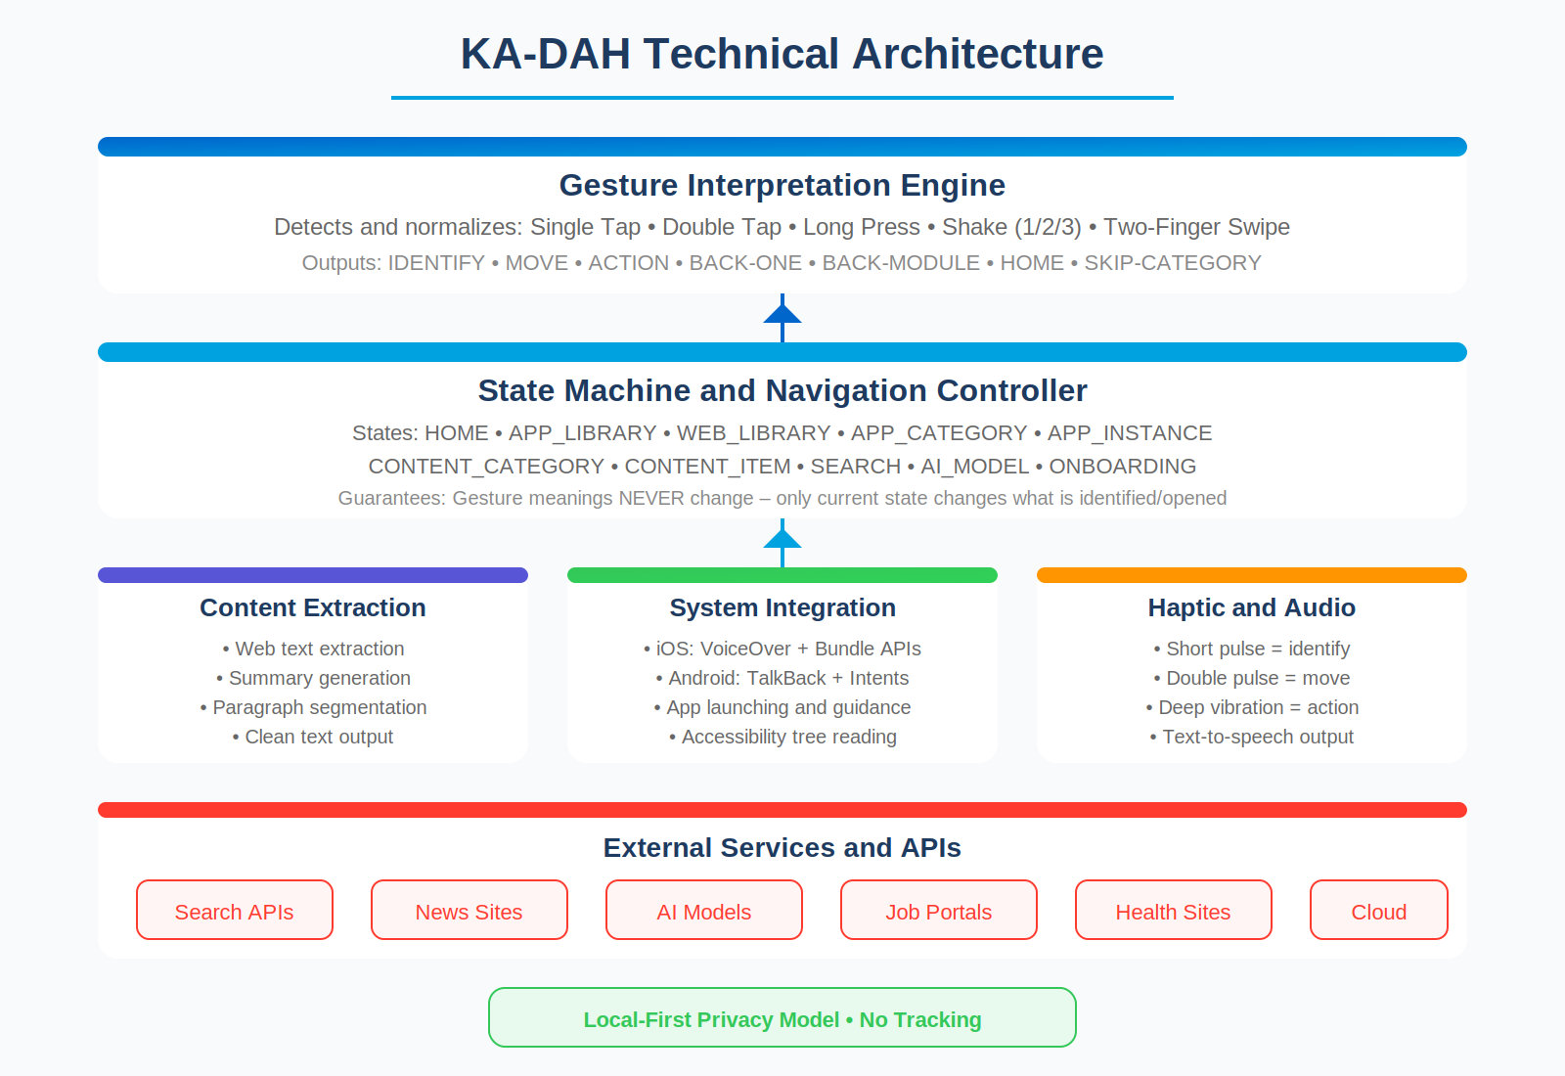
Figure 12.1: KA-DAH Technical Architecture

12.2 Four Core Subsystems
- Gesture Interpretation Engine - Detects and normalizes user input
- State Machine and Navigation Controller - Manages valid states and transitions
- Content Extraction and Summarisation Engine - Fetches and simplifies web content
- System Integration Layer - Connects apps, web, and AI tools

12.3 Gesture Interpretation Engine
Responsibilities:
- Debounce noisy touches and unintentional taps
- Detect tap vs long press timing reliably
- Distinguish one, two, and three shakes
- Convert raw input into universal commands

12.4 App Integration Layer

iOS Integration
- Uses existing APIs to launch apps by bundle identifier
- Leverages VoiceOver and the accessibility tree
- Uses labels and traits to understand key actions

Android Integration
- Uses intents to open apps
- Uses Accessibility Services and view hierarchy
- Identifies common controls and screens

Section 13: Security and Privacy Architecture
KA-DAH's security model protects VI users who often face digital risks related to data exposure and inaccessible permissions.

13.1 Privacy Philosophy
- User dignity first
- Local-first storage
- Explicit user action required
- Minimal permissions
- Full transparency

13.2 Data Classification

Core Functional Data (Stored Locally)
- App list, website list, AI tools list
- User preferences (haptics, speech rate, tone)
- Category assignments

Ephemeral Data (Temporary Only)
- AI prompts and search queries
- Extracted content and state logs

External Data (Never Stored)
- Message contents, call contents
- Banking data, browser history
- AI conversation history beyond current session

13.3 Permission Model
KA-DAH requests only:
- Accessibility Services
- Microphone (for voice input)
- Network access
- Vibration

KA-DAH will NOT request: Contacts, Photos, Camera, or Location (unless mobility apps added).

Section 14: Performance and Reliability Requirements
KA-DAH must perform reliably under real-world conditions including poor networks and diverse device capabilities.

14.1 Performance Principles
- Predictability: Every gesture yields consistent, immediate response
- Low Latency: Core actions must feel instantaneous
- Stability: Responsive across all devices
- Graceful Degradation: Failures return user to safety

14.2 Latency Requirements
- Gesture interpretation: Under 100ms
- Speech recognition startup: Under 300ms
- Local summary generation: Under 1 second
- Web extraction: 0.5-2.0 seconds (network dependent)
- AI summary response: 1-4 seconds (model dependent)

14.3 Offline Behaviour
When offline, KA-DAH maintains full gesture navigation:
- App Library access
- Web Content categories (with empty state prompts)
- App launching (offline apps only)
- AI tools: 'Network unavailable. Shake to go back.'

14.4 Battery Optimization
KA-DAH avoids background location, persistent network activity, and open microphone sessions. Target: Under 3% battery per hour active use.

Section 15: Multi-Device and Hardware Considerations
KA-DAH must function consistently across a wide spectrum of devices used throughout Africa and globally.

15.1 Device Diversity
VI users often rely on:
- Older second-hand smartphones
- Entry-level Android phones with limited RAM
- Phones with damaged screens
- Devices with weak vibration motors
- Budget phones with slower processors

15.2 Android Fragmentation Strategy
- Gesture detection calibrated to wide thresholds
- Adaptive haptic strength based on device capabilities
- Rely on core Android Accessibility Services
- Provide fallback audio cues where haptics are weak

15.3 Hardware Failure Modes
If hardware components fail:
- No vibration: Audio-only fallback
- No microphone: 'Voice input unavailable. Shake to go back.'
- No network: Offline mode
- TTS failure: Fallback tone patterns

15.4 Target OS Versions
- Android 10 and above
- iOS 15 and above

Section 16: Invisible Screens and Prototyping Flows
This section presents KA-DAH's invisible screens: blank states with voice guidance, haptic patterns, and gesture-based transitions.

16.1 Notation Format
Each screen is described with: VOICE (what system says), HAPTICS (vibration pattern), GESTURES (allowed actions), PURPOSE (why this state exists).

16.2 Home State Screen
VOICE: 'KA-DAH. Home State.'
HAPTICS: Long soft vibration (Home signature)
PURPOSE: Establish calm, orientation, and immediate usability

16.3 App Library Category Screen
VOICE: 'Communication. Category 1 of 6.'
HAPTICS: Short pulse
PURPOSE: Prevent overwhelming lists

16.4 Error State Screen
VOICE: 'Something went wrong. Shake to go back.'
HAPTICS: Long single vibration
PURPOSE: Offer absolute safety and escape

16.5 AI Prompt Mode Screen
VOICE: 'Say your question after the tone.'
HAPTICS: Deep vibration plus tone
PURPOSE: Remove complexity - Long Press equals Speak

Section 17: Implementation Roadmap
KA-DAH's implementation progresses through three structured releases to balance technical feasibility, user safety, and rapid delivery.

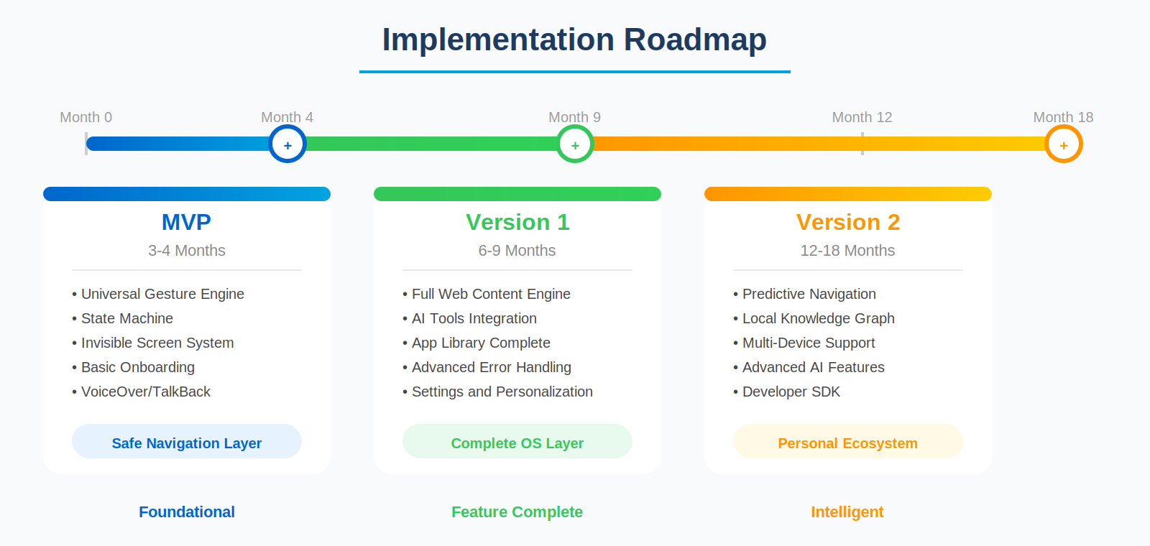
Figure 17.1: Implementation Roadmap Timeline

17.1 MVP (3-4 Months)
Establishes KA-DAH as a safe, predictable non-visual interface:
- Universal Gesture Engine with forgiveness window
- State Machine with Home State and App Library
- Invisible Screen System with Voice plus Haptic output
- Basic Onboarding with gesture tutorial
- VoiceOver and TalkBack compatibility

17.2 Version 1 (6-9 Months)
Completes KA-DAH's two core pillars:
- Full Web Content Engine with summary generation
- AI Tools integration (ChatGPT, Claude, Gemini)
- App Library enhancements (add/remove/reorder)
- Advanced error handling with retry logic
- Settings for speech rate, haptic intensity

17.3 Version 2 (12-18 Months)
The intelligence release:
- Predictive Navigation Engine learning user patterns
- Local Knowledge Graph for adaptive shortcuts
- Cross-device expansion (tablets, smartwatches)
- Developer SDK for third-party integration

Section 18: Risk Register and Mitigations
This section outlines major risks across technical, operational, legal, and user-experience domains.

18.1 Technical Risks

R1: Gesture Misinterpretation
Risk: False positives or incorrect detection
Mitigation: Gesture forgiveness window, vibration confirmation, shake-to-safety

R2: Weak Performance on Low-End Devices
Risk: Slow voice output, lag
Mitigation: Lightweight architecture, caching, reduced background tasks

R3: TTS System Failure
Risk: Device TTS unavailable
Mitigation: Fallback tone cues, simple retry, shake-back safe point

18.2 User Experience Risks

R5: Cognitive Overload
Risk: Too many items, too many steps
Mitigation: Chunked reading, summaries, predictable list structures

R6: Inconsistent Gesture Meaning
Risk: Confusion across screens
Mitigation: Universal gesture rules enforced at system level

18.3 Security Risks

R10: Sensitive Voice Data Exposure
Risk: Prompts captured by cloud apps
Mitigation: Explicit consent, local-first processing, encrypted channels

Section 19: Future Extensions and Hardware Integrations
KA-DAH's long-term vision expands beyond mobile into a multi-device accessibility ecosystem.

19.1 Multi-Device Extensions
- Tablets: Larger haptic motors, better speakers, identical gesture model
- Smartwatches: Wrist-based haptic cues, quick actions
- Smart Speakers: Voice-first home navigation, 'Ask KA-DAH' commands

19.2 Wearable Hardware
- Bone-Conduction Headphones: Discreet listening, improved mobility safety
- Tactile Feedback Bands: Subtle directional nudges
- Smart Glasses (Long-term): Non-visual overlays, object detection

19.3 Environmental Intelligence
- Noise-Aware Mode: Automatically switches to haptic-first cues
- Motion-Aware Mode: Reduces shake sensitivity when walking

19.4 Advanced Software Intelligence
- Predictive Navigation: Learns patterns, anticipates tasks
- Context Memory: Remembers last articles, apps, categories
- Proactive Suggestions: 'Would you like to continue yesterday's article?'

19.5 Developer Ecosystem
SDK for third-party apps to register accessible features, enabling a KA-DAH ecosystem of accessible applications.

Section 20: Compliance, Policy, and Global Standards
KA-DAH must meet and exceed global accessibility standards to guarantee dignity, safety, legal compliance, and interoperability.

20.1 Core Global Frameworks

WCAG 2.2
- Perceivable: Non-visual output through voice plus haptics
- Operable: Fully gesture-driven controls
- Understandable: Predictable state machine
- Robust: Compatible with VoiceOver, TalkBack, future assistive tech

EN 301 549 (EU Standard)
- Non-visual operability requirements
- Speech output expectations
- Input modality independence

ADA and Section 508 (USA)
- Digital accessibility compliance
- Public service access through apps
- Hardware-agnostic accessibility

20.2 Privacy Regulations
- GDPR (European Union): Local-first processing, explicit consent, data minimization
- POPIA (South Africa): Protection of spoken prompts, strict consent, no tracking

20.3 Ethical Accessibility Principles
- Dignity First: No forced voice interaction, haptic-only fallback
- Independence: Zero reliance on sighted assistance
- Cognitive Simplicity: Small lists, predictable gestures, summaries first

20.4 Ongoing Compliance
- Annual Accessibility Audit
- User Advisory Council (VI-led) with quarterly testing
- Continuous monitoring of global accessibility standards

Appendix: Quick Reference Guide

Universal Gesture Reference
- Single Tap: IDENTIFY - Read current item
- Double Tap: MOVE - Go to next item
- Long Press: ACTION - Open, confirm, or voice input
- Shake Once: BACK ONE - Previous level
- Shake Twice: BACK MODULE - Previous module
- Shake Three Times: HOME - Return to Home State
- Two-Finger Swipe: SKIP CATEGORY - Jump lists (optional)

Haptic Patterns
- Short pulse: Action confirmed
- Double pulse: Movement/navigation
- Deep vibration: Action accepted
- Long soft vibration: Home State reached

Home State Options
- App Library: Phone, Messages, WhatsApp, Uber, Maps, Settings, Help
- Web Content: News, Stories, Education, Jobs, Health, Search, AI Models

Key Design Principles
- Gestures NEVER change meaning
- Summaries come before full content
- Local-first privacy with no tracking
- Shake always returns to safety
- Voice is optional, never forced

